Edward Auttonberry

**Lab 2: Introduction to Kinematics Using the Motion Sensor**

6/6/2018

PHYS 261 – 005

With:

Zac Davis

and

Tyler Perry

**Objective**

The objective of this lab was to familiarize ourselves with the relationship between the position, velocity, and acceleration of objects in motion and to visualize them using the respective graphs of each value over time of a cart rolling on a track.

**Theory**

The theory being tested in this lab is the derivative relationship of acceleration to velocity, and velocity to position, over time. The tool we are using the measure these values is an ultrasonic motion detector, which emits high-frequency sound waves and computes the distance to an object in its scope based on how long it takes an emitted wave to return to the device’s sensor and the speed of sound. The LoggerPro software calculates the velocity and acceleration based on the periodic position values.

Both LoggerPro and we will be using kinematic equations to calculate the velocity and acceleration over a periodic interval Δt. On this period, the velocity of an object in motion is given by

$v\left(t\right)=\frac{∆x}{∆t}$ Eq. 2-1

where Δx is the distance between the object’s position at the beginning and the end of the periodic interval. Likewise, the acceleration of the object is given by

$a\left(t\right)=\frac{∆v}{∆t}$ Eq. 2-2

given that the object is experiencing a velocity *v* found as prior.

In some special cases of the object’s state, certain variations of the kinematics formulae are given. For example, if the object is experiencing null acceleration, its velocity is therefore constant making the equation

$v=v_{0}$ Eq. 2-3a

true for all *t*. This makes the absolute position predictable, given that the initial position is known, by the equation

$x=vt+x_{0}$ Eq. 2-3b

This is a concept that can be applied identically a step down, given that the acceleration of the object is a non-zero constant value.

$v=at+v_{0}$ Eq. 2-4a

When Eq. 2-4a is substituted into Eq. 2-3b, we derive an essential kinematic formula:

$x=\frac{1}{2}at^{2}+v_{0}t+x_{0}$ Eq. 2-4b

For the first two procedures, the objects in motion experience movement on a flat plane, and therefore a constant null acceleration. The latter two take into consideration an inclined plane. In these cases, the acceleration will be a proportion of the gravitational constant as defined by the angle θ of the incline

$a=g*\sin{θ}$ Eq. 2-5

Eq. 2-1 and Eq. 2-2 are statements that assert that acceleration is the slope of the velocity, which is in turn the slope of the position. The accuracy of this relationship is however considerably reliant on a high sampling rate.

**Procedure**

The procedures for this lab are very straightforward. A motion detector was set up to take position measurements on objects in motion for all four procedures.

Procedure A involved taking the measurements of the position of a person moving toward the motion detector from afar, and then, in a separate measurement, the measurements of the position of that person moving away from the detector. The remaining procedures all employed the use of a cart on a frictionless(ish) track. In Procedure B, the measurements were taken on the cart as it moved toward the sensor at a constant velocity. Procedure C saw the cart released from rest at the top of the track propped to an incline by a wooden block, and Procedure D involved applying a force to the cart from the bottom end of the track at the same incline.

**Data**

Shown below is the plot of the two measurements for Procedure A.

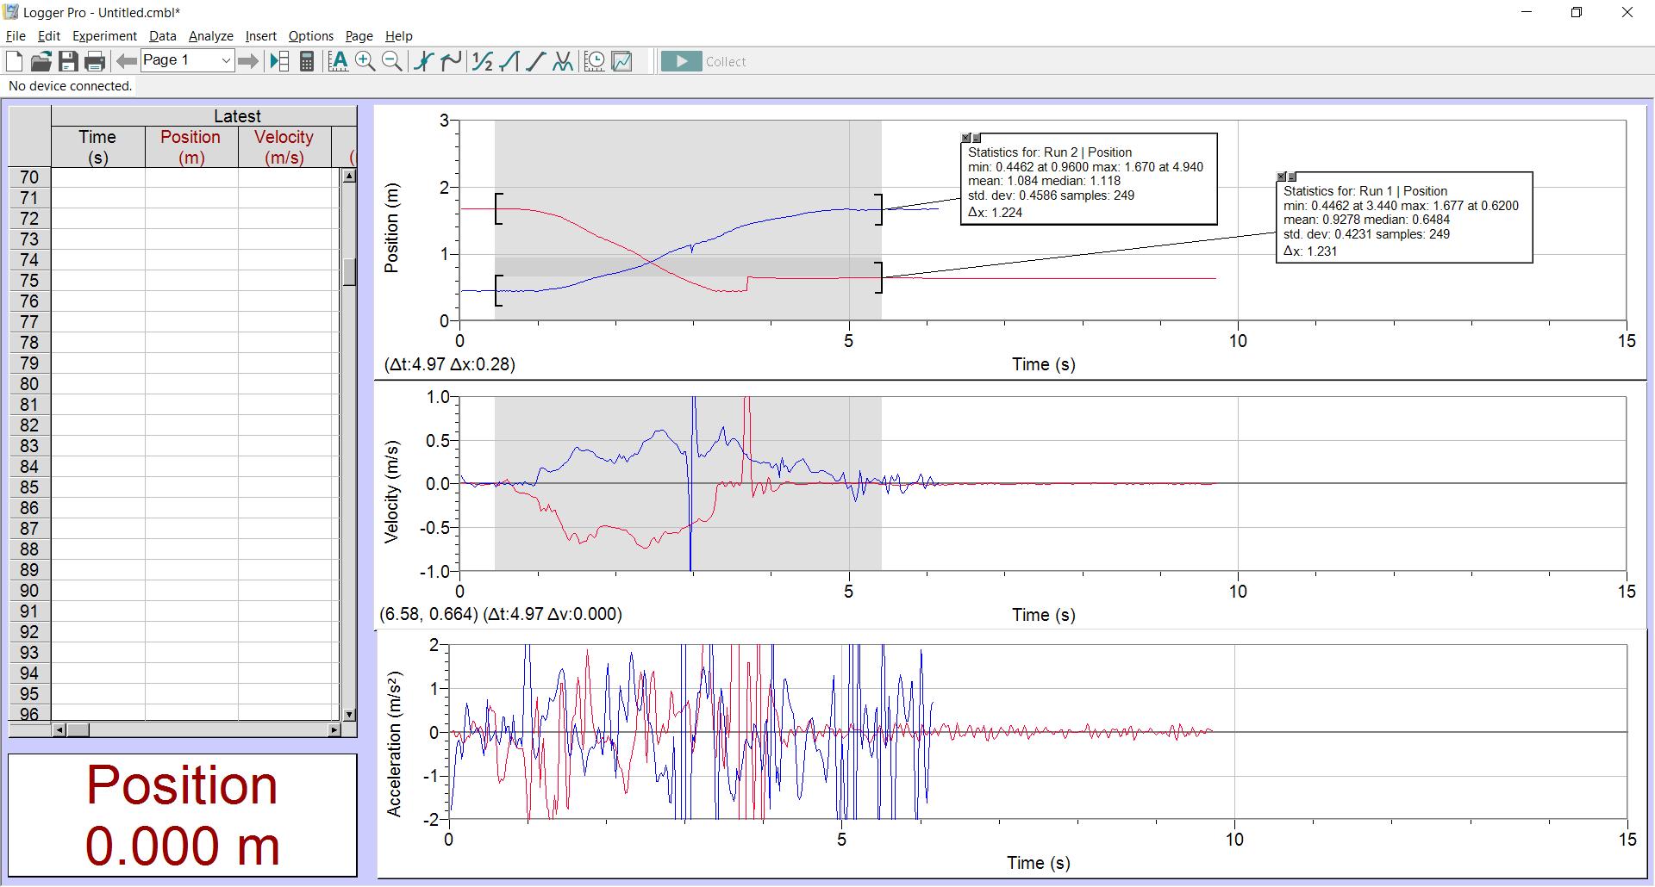

**Figure 2-1.** The measurements and attributes of a person walking towards and away from the sensor. The red plot contains the data for the person walking towards, and the blue represents a person walking away.

Below are the graphs for Procedure B.

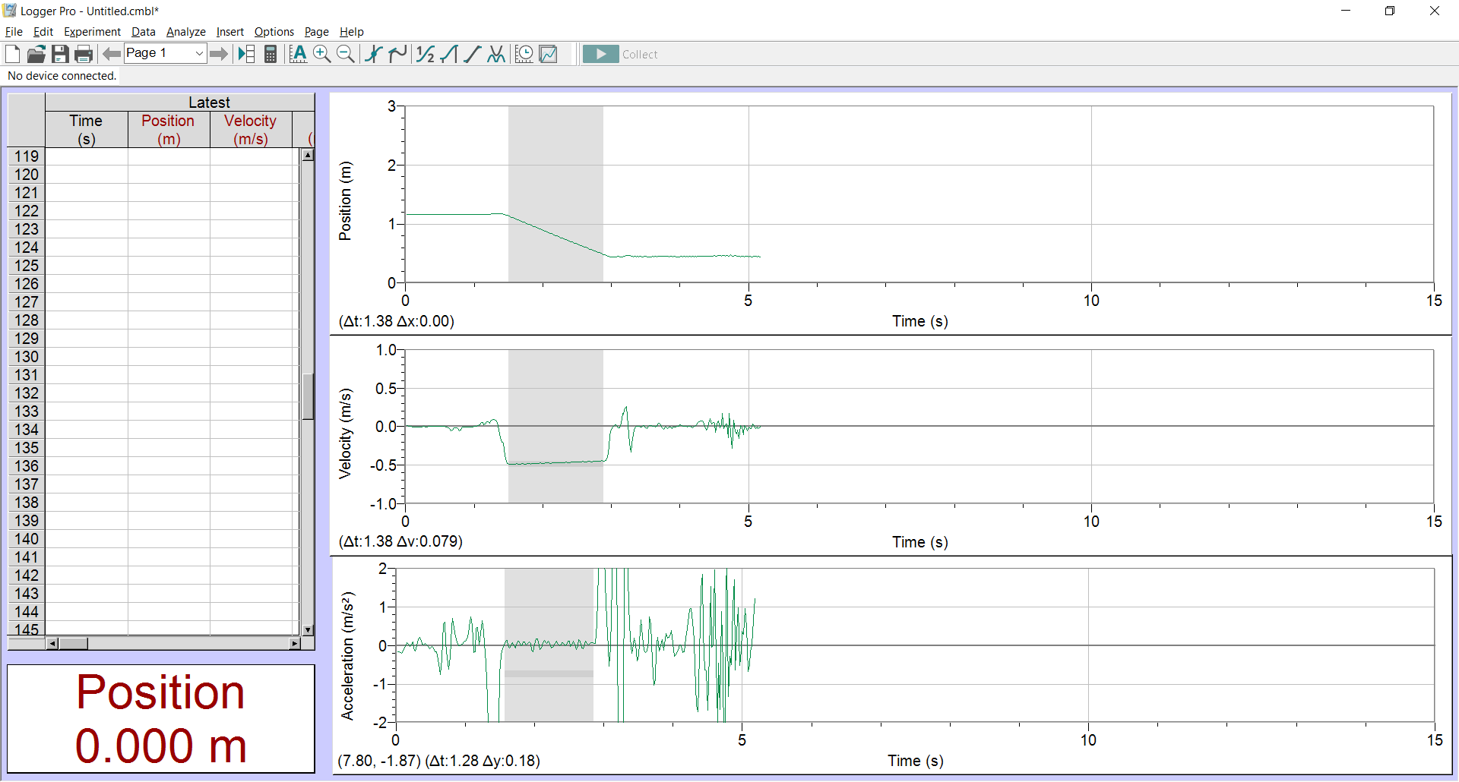

**Figure 2-2.** The graphs of the position, velocity, and acceleration of the cart moving across the track after an initial push. The period in which the cart is moving is identifiable by the change in position of the cart, a nonzero constant velocity, and a zero-acceleration preceded by a sharp negative spike and followed by a sharp positive spike.

Below are the graphs for Procedure C.

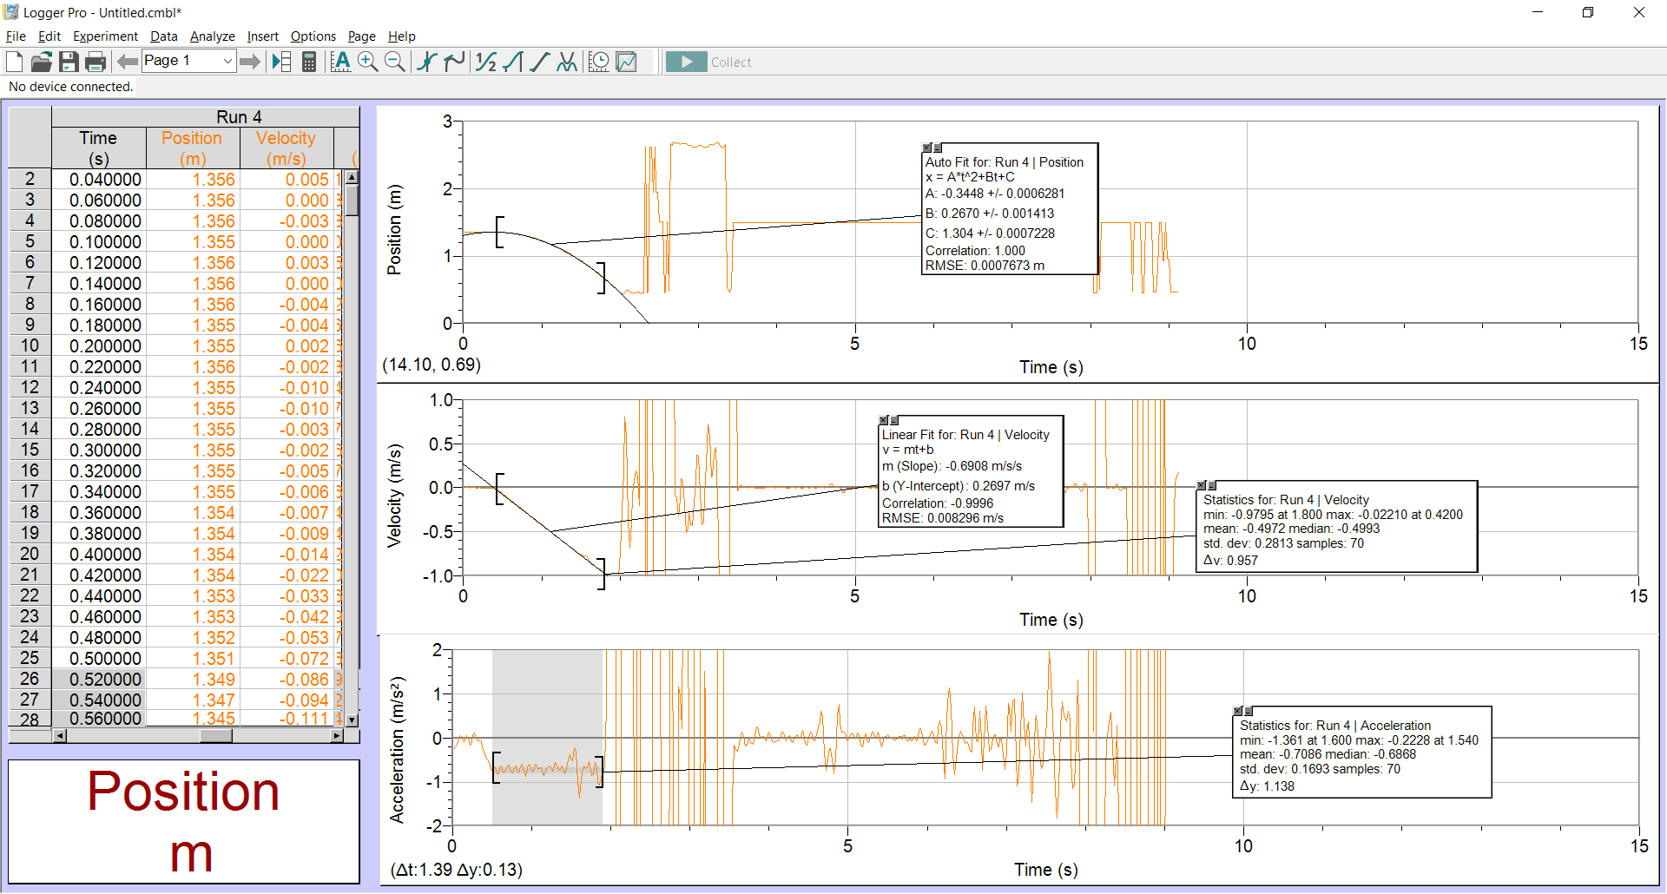

**Figure 2-3.** Here we have the relevant graphs for procedure B. acceleration now takes a non-zero constant, so the other two graphs change accordingly.

Finally, we have the graphs for Procedure D.

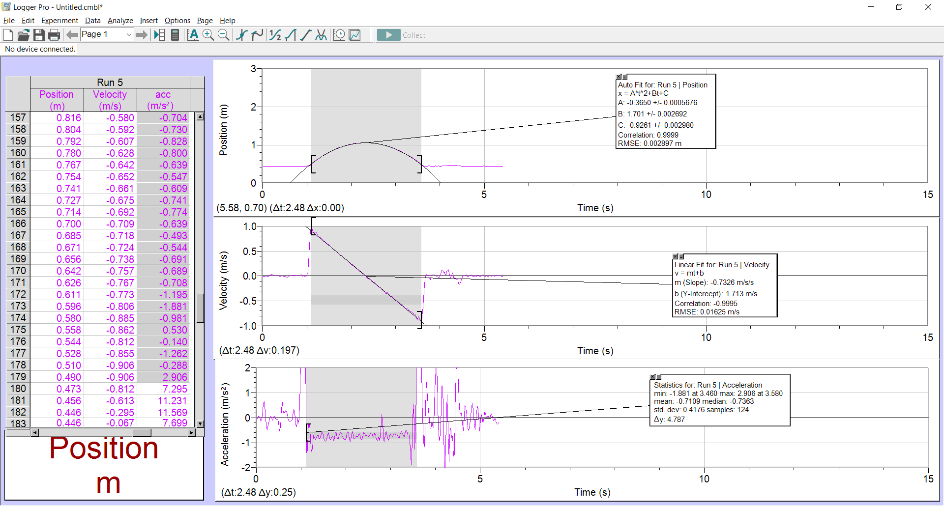

**Figure 2-4.** The above contains the same respective graphs for Procedure D as Figure 2-3.

**Analysis**

**Procedure A**

The graphs of Procedure A in Table 3-1 provide clear correlation between the changes in position, velocity, and acceleration of the person in motion. During the period in the graphs, before and after motion in either direction, the position was constant while the velocity was relatively flat on zero. Only once the position began to change did the velocity take a non-zero value. At this point also, a spike occurs in the acceleration, though it is difficult to identify due to the high amount of noise in the acceleration graph. A spike like this occurs again at the end when the motion stops. In these trials, when the velocity takes a negative value, then the position tends to decrease, and vice-versa. The same relationship is also visible between velocity and acceleration: a negative acceleration correlates with a decreasing velocity, and vice-versa.

**Procedure B**

Below is a table containing the attributes and the calculations performed thereon of the plots in Figure 2-2.

|  |  |  |  |
| --- | --- | --- | --- |
| Procedure B: Level Track | |  |  |
| Quantity measured | value | uncertainty | percent difference |
| slope of x-curve | -0.4695 |  | 0.021299255 |
| average of v-curve | -0.4694 | 0.01371 |
| slope of v-curve | 0.03337 |  | 4.16541804 |
| average of a-curve | 0.03476 | 0.07177 |

**Table 2-1.** Table containing correlative information about the plots in Figure 2-2. The table is sectioned into relationship between position and velocity, and velocity and acceleration. The values of the slopes of one should match closely to the values of the averages of the counterparts.

Because the cart was moving along a level track, and only experienced a momentary initial force to gain momentum, we expect a relatively constant velocity. The velocity graph in Figure 2-2 shows that the velocity is not quite constant throughout the period of motion, but the average of the acceleration graph matches quite closely and the error between the two is less than 5%. The discrepancy between the position slope and the velocity average is almost zero.

**Procedure C**

This time, the velocity of the cart is not a constant because the cart experiences a non-zero acceleration throughout the trial period. The velocity graph for the period, as visible in Figure 2-3, is linear. To show the continuance of the relationship between the velocity and the position slope, we use a curve fit on the position graph. We do not use a linear fit because we expect the position graph to take a quadratic form. The quadratic fit forms nicely to the position plot, and that shows that the velocity relationship that we expect from Eq. 2-4 and see in the graph is valid: the position decreases exponentially as the velocity decreases linearly. Then there is the velocity-acceleration relation. Below is a table containing the same relevant information for Procedure C from Figure 2-3.

|  |  |  |  |
| --- | --- | --- | --- |
| Procedure C: Top of Inclined Track from Rest | | | |
| Quantity measured | value | uncertainty | percent difference |
| slope of v-curve | -0.6908 |  | 2.57672264 |
| average of a-curve | -0.7086 | 0.1693 |

**Table 2-2.** The table containing information about the graphs for the velocity and acceleration of the cart on the incline.

Again, the slope of the velocity graph matches the average acceleration within a 2% margin.

**Procedure D**

In Procedure D, the cart is pushed against gravity up the inclined cart, but we still see the same relationship between the position and velocity. Whenever the velocity is positive, the curve rises, and vice-versa, and the slope of he curves becomes ever-more-so horizontal as the velocity graph approaches zero. And again, the same analysis is applicable to the velocity-acceleration relationship.

|  |  |  |  |
| --- | --- | --- | --- |
| Procedure C: Cart Rolling Up and Down Ramp | | | |
| Quantity measured | value | uncertainty | percent difference |
| slope of v-curve | -0.7326 |  | 2.962052962 |
| average of a-curve | -0.7109 | 0.4176 |

**Table 2-3.** The table of attributes for the graphs of Figure 2-4.

The slope of the velocity curve is unsurprisingly quite close to the average of the acceleration curve, just as in the others.

**Conclusions**

We have performed analysis of four different mediums of motion of an object and determined that the laws of kinematics are closely followed even with the obvious errors in the technology and measurements, such as the acceleration readings in Figure 2-1. Other than this, the readings were very easy to follow, and the relationships between the three kinematic values over the same collection period are clear. Thus, the objective of the lab has been achieved and the theory holds fast.